SELECTED ENGINEERING PROBLEMS
NUMBER 8
INSTITUTE OF ENGINEERING PROCESSES AUTOMATION
AND INTEGRATED MANUFACTURING SYSTEMS

First Name SURNAME^{1*}, Jan KOWALSKI² (TNR 12 Pt.)
¹ Institute/Department, Faculty, University, Town (headquarters) (if the same for all authors - omit the superscript next to the names, if the same for several authors - enter once)
* Corresponding author e-mail address (TNR 12 Pt.)
PAPER TITLE (TNR 14pt. bold)
Abstract: Summary with the documentary character. Content of the paper abstract should contain no more than 150 words. Use font Times New Roman 12 pt., single line spacing, with the full text adjustment.
- Introduction
Synthetic description of approach with an indication of the original elements of the work. In a main part of article font Times New Roman 12 pt. without leading should be used; full adjustment of the text, using 0,5 cm of indentation on the first line of the paragraph. Please keep the arrangement according to the pattern. Left and right margins should be 2,5 cm, while the top and bottom 3,5 cm.
The article should not exceed 4 or 6 full A4 pages. Please send papers in .doc and .pdf formats, compressed to ZIP archive on malgorzata.olender@polsl.pl. Files should be named by giving surname and name of first author, as well as the article number, by using the following pattern: KOWALSKI_JAN_1.doc. and KOWALSKI_JAN_1.pdf.
- Title of chapter
Equations, figures and graphs should be an integral part of text and should be numbered:
(single line of spacing TNR 12 Pt.)
. (1)
(single line of spacing TNR 12 Pt.)
In addition, tables and figures should be signed as shown below. Please prepare a good quality drawings and diagrams to be legible when printed in black-white. Figures and graphs subscriptions should be centered and not ended with dot. Tables descriptions should be placed above them and be align to the right edge of the table, not ended with dot.
(single line of spacing TNR 12 Pt.)
Tab. 1. Table title
 | Value 1 | Value 2
1 | 100 | 200
2 | 300 | 400
(single line of spacing TNR 12 Pt.)
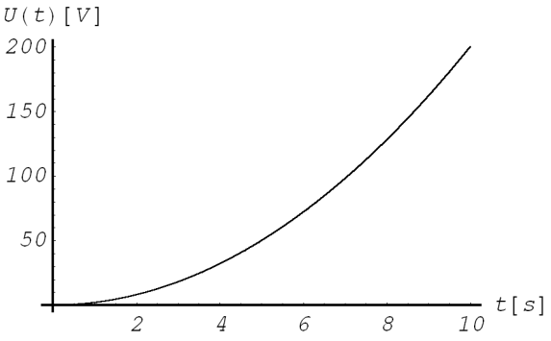
Fig.1. Figure title
- Conclusion
Papers prepared without accordance with the specified format will be returned to authors to make corrections!
All papers are sending to the expert for their review. The reviewers’ recommendations determine whether a paper will be accepted/ accepted subject to change/ rejected.
The Editor-in-Chief reserves the right to refuse any typescript, whether on invitation or otherwise, and to make suggestions and/or modifications before publication. Typescripts, which have been accepted, become the property of the Publisher. It is a condition of acceptance that copyright shall be vested in the Publisher. The Publisher shall not be held responsible for errors, which are the result of authors' oversights.
References (TNR 12 pt.)
Publishing compact (one, two or three authors)
Surname and first letter of name: Title. Place of publication: publisher, year of publication.
An example:
Smith J.: Some book title. London: Springer, 1995.

Complete publications (more then three authors – collective work)
Title. Work editor. Place of publication: publisher, year of publication.
An example:
Some book title. Smith J. (Ed.): London: Springer, 2001.

Publishing as a part of a larger whole (eg. conference materials)
Surname and first letter of name: Title: W: Name of the conference. Place of conference, year, pages
An example:
Smith J., Jones M.: Some paper title. In: 3rd International Conference „New Science”. Warsaw, 2000, pp. 111 – 116.

Publishing in the journal
Surname and first letter of name: Paper title. „Title of the magazine” year, number or volume number, pages
An example:
Smith J.: Some paper title. „International Journal of Science” 1988, Vol. 15, pp. 13 – 21.

- Smith J.: Some book title. London: Springer, 1995.
- Some book title. Smith J. (Ed.): London: Springer, 2001.
- Some paper title. In: 3rd International Conference „New Science”. Warsaw, 2000, pp. 111 – 116.
- Smith J.: Some paper title. „International Journal of Science” 1988, Vol. 15, pp. 13 – 21.

When quotation online publications the date of access should be specified.

